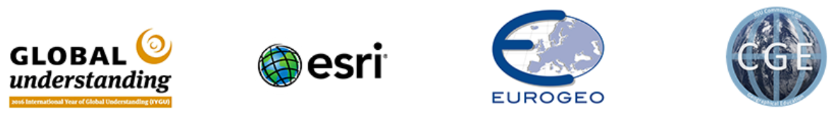

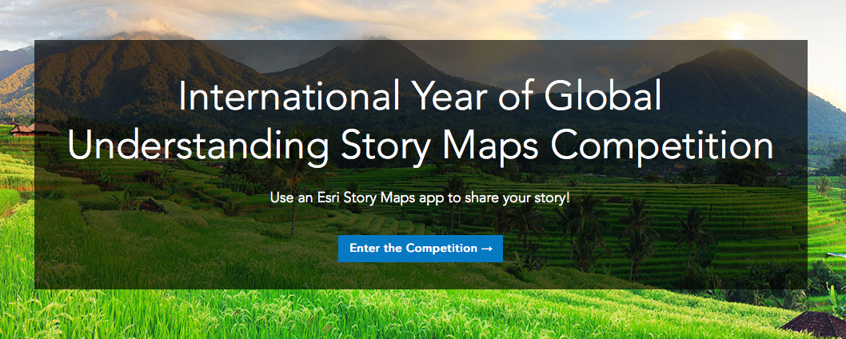

Calling all higher education students to Tell Your Story!
The International Year of Global Understanding
Story Maps Competition
Use the Esri Story Maps app to share your story!

Together with EUROGEO, Esri, and the International Geographic Union Commission for Geographic Education, the International Year of Global Understanding (IYGU) has launched a Story Maps Competition. All higher education students (age 19-30) doing research in one of these themes are encouraged to enter! Using the Esri Story Maps apps, you should create a concise story map that connect the local action with its global implications for a chance to win one of three prizes!

To get started go to the competition website to register. Get started with your own ArcGIS Online Account or get a free, non-commercial account

The competition opens on the 26th September and closes 31st December. Winners will be announced 15th March 2017.

For more information
Visit the competition website to see the official rules and terms and conditions, as well as answers to frequently asked questions. Visit the International Year of Global Understanding for more information about the IYGU

Benno Werlen – IYGU
Karl Donert – EUROGEO
Kathrin Viehrig – CGE

